**DAILY ONLINE ACTIVITIES SUMMARY**

|  |  |  |  |  |  |  |  |  |
| --- | --- | --- | --- | --- | --- | --- | --- | --- |
| **Date:** | **27/05/2020** | | | | | **Name:** | **POOJA D S** | |
| **Sem & Sec** | **4th SEM 'B' Section** | | | | | **USN:** | **4AL18CS056** | |
| **Online Test Summary** | | | | | | | | |
| **Subject** | | **Object Oriented Concept** | | | | | | |
| **Max. Marks** | | **30** | | **Score** | | | **25** | |
| **Certification Course Summary** | | | | | | | | |
| **Course** | **Cloud Foundations** | | | | | | | |
| **Certificate Provider** | | | **Great Learning Academy** | | **Duration** | | | **4.5 hour** |
| **Coding Challenges** | | | | | | | | |
| **Problem Statement:** A user will input two strings, and we find if one of the strings is a sub sequence of the other. Program prints “yes” if either the first string is a sub sequence of the second string or the second string is a sub sequence of the first string. Assume that, the length of the first string is smaller than or equal to the length of the second string. Assume that, the length of the first string is smaller than or equal to the length of the second string. | | | | | | | | |
| **Status: completed** | | | | | | | | |
| **Uploaded the report in Github** | | | | | **yes** | | | |
| **If yes Repository name** | | | | | <https://github.com/dspooja/C-coding> | | | |
| **Uploaded the report in slack** | | | | | **yes** | | | |

Online Test Details: (Attach the snapshot and briefly write the report for the same)

Certification Course Details: (Attach the snapshot and briefly write the report for the same)

Coding Challenges Details: (Attach the snapshot and briefly write the report for the same)

ONLINE TEST DETAILS:

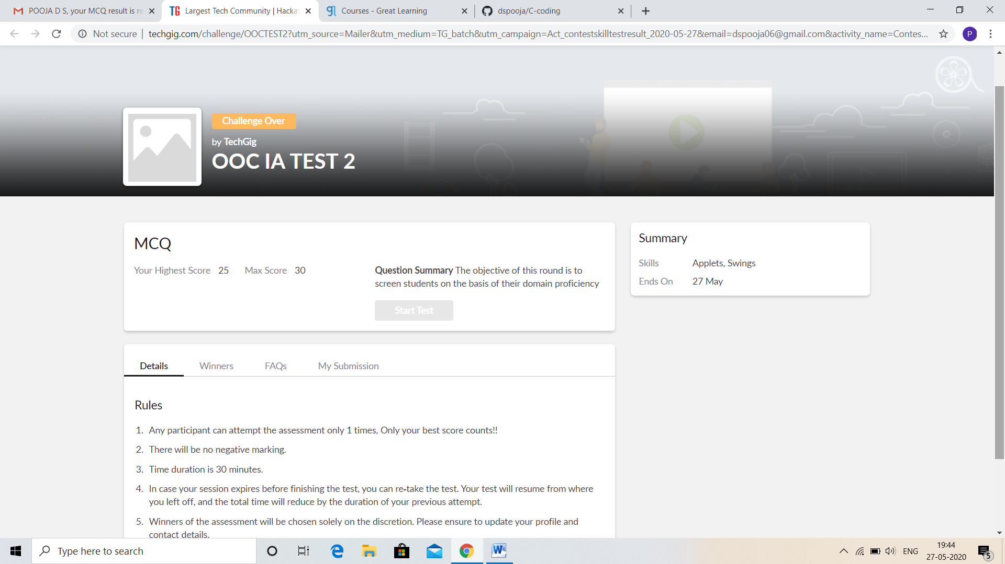

CERTIFICATION COURSE DETAILS:

* I begins new certification course that is Cloud Foundation.
* **The concepts covered in** Cloud Foundation **are:**
* Definitions, Stories & Business Concerns
* Classical Enterprise, Why Cloud & Evolution of Cloud
* Service Models, Abstraction Levels, SPIDERS
* Cloud Attributes, Managed Services & Deployment Models
* Pricing & Scaling Models

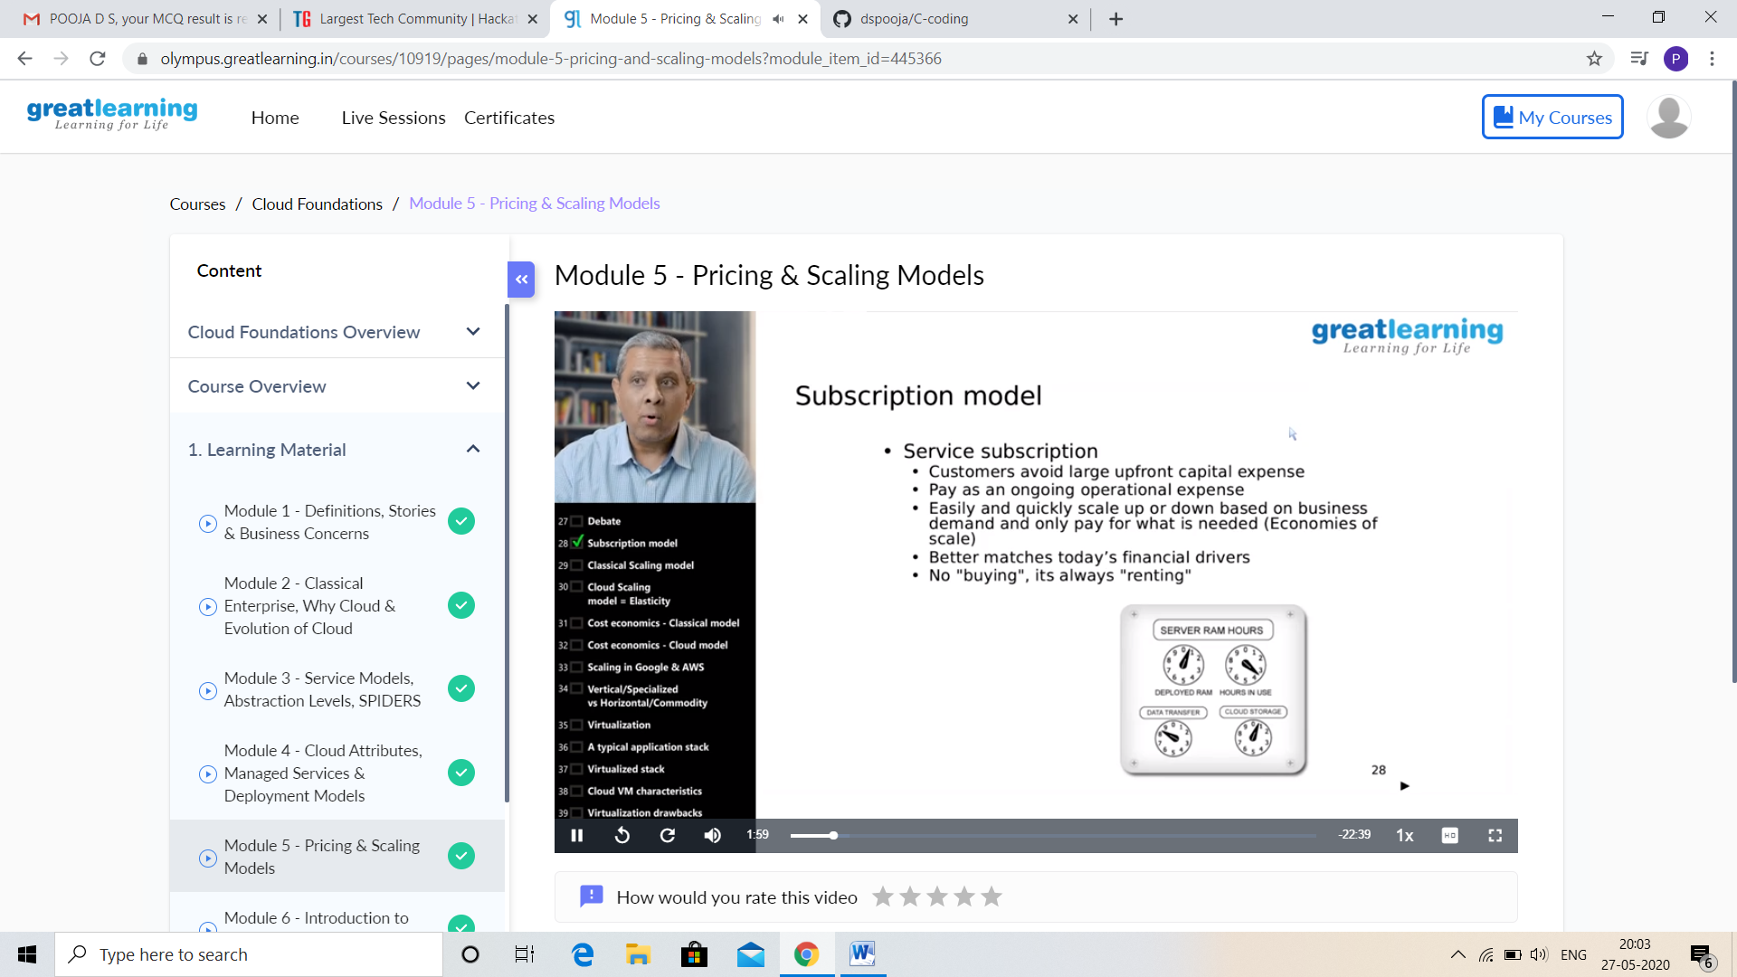

And I attend Webinar on Chatbot(IETE Sponsored) and BCI(NITK Sponsored)-Free E Certificate



CODING CHALLENGES DETAILS:

Problem statement 1:

In Bubble sort, each pass consists of comparison each element in the file with its successor (i.e. x[i] with x[i+1]) and interchanging two elements if they are not in the proper order. The array may be sorted in any pass. If the array is sorted, then remaining passes should be skipped off. Write a C Program to sort an array of integers in ascending order and display the sorted array and Number of passes performed for sorting.

Solution : Uploaded it in github

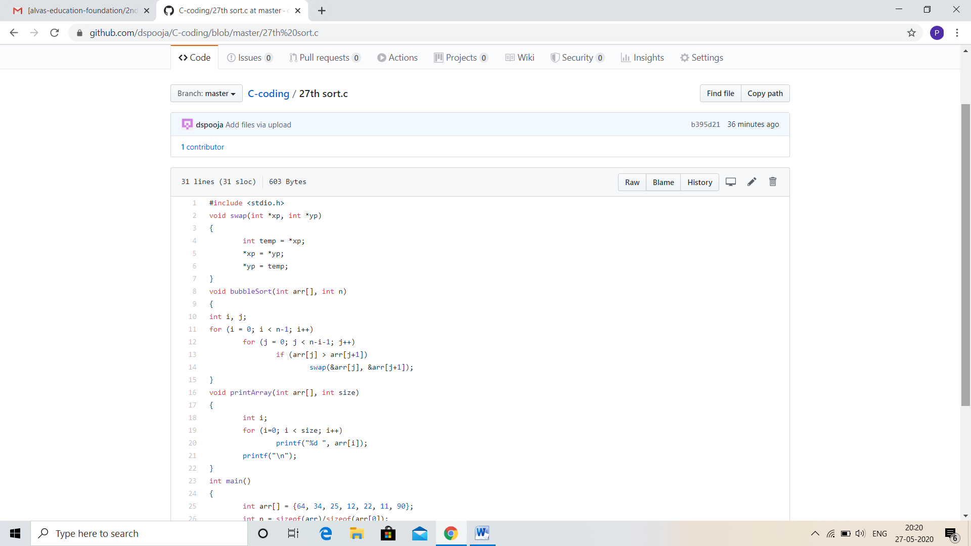

Problem statement 2:

Given an array arr[] of the positive integers of size N, the task is to find the largest element on the left side of each index which is smaller than the element present at that index. Note: If no such element is found then print -1.

Input: arr[] = {2, 5, 10}  
Output: -1 2 5  
Explanation :  
Index 0: There are no elements before it  
So Print -1 for the index 0  
Index 1: Elements less than before index 1 are – {2}  
Maximum of those elements is 2  
Index 2: Elements less than before index 2 are – {2, 5}  
Maximum of those elements is 5

Input: arr[] = {4, 7, 6, 8, 5}  
Output: -1 4 4 7 4  
Explanation :  
Index 0: There are no elements before it  
So Print -1 for the index 0  
Index 1: Elements less than before index 1 are – {4}  
Maximum of those elements is 4  
Index 2: Elements less than before index 2 are – {4}  
Maximum of those elements is 4  
Index 3: Elements less than before index 3 are – {4, 7, 6}  
Maximum of those elements is 7  
Index 4: Elements less than before index 4 are – {4}  
Maximum of those elements is 4

Solution: Uploaded in github.

